# Game Constants

import pygame

import random

import os

# Initialize

pygame.init()

WIDTH, HEIGHT = 800, 600

SCREEN = pygame.display.set_mode((WIDTH, HEIGHT))

pygame.display.set_caption("Base Strike")

CLOCK = pygame.time.Clock()

# Load images and sounds

ASSET_DIR = "assets"

IMAGES = {

    "base1": pygame.image.load(os.path.join(ASSET_DIR, "C:\\Users\\vignan\\Downloads\\base1.png.jpeg")),

    "base2": pygame.image.load(os.path.join(ASSET_DIR, "C:\\Users\\vignan\\Downloads\\base2.jpeg")),

    "light": pygame.image.load(os.path.join(ASSET_DIR, "C:\\Users\\vignan\\Downloads\\misile1.jpeg")),

    "heavy": pygame.image.load(os.path.join(ASSET_DIR, "C:\\Users\\vignan\\Downloads\\misile2.jpeg")),

    "emp": pygame.image.load(os.path.join(ASSET_DIR, "C:\\Users\\vignan\\Downloads\\misile3.jpeg")),

}

SOUNDS = {

    "missile": pygame.mixer.Sound(os.path.join(ASSET_DIR, "sounds/missile.wav")),

    "explosion": pygame.mixer.Sound(os.path.join(ASSET_DIR, "sounds/explosion.wav")),

    "block": pygame.mixer.Sound(os.path.join(ASSET_DIR, "sounds/block.wav")),

    "alert": pygame.mixer.Sound(os.path.join(ASSET_DIR, "sounds/alert.wav")),

}

# Game Constants

BASE_HEALTH = 100

START_CURRENCY = 1000

MISSILES = {

    "light": {"cost": 100, "damage": 10},

    "heavy": {"cost": 300, "damage": 30},

    "emp": {"cost": 200, "damage": 0},

}

DEFENSE_COOLDOWN = 3000  # milliseconds

# Game State

players = [

    {"health": BASE_HEALTH, "currency": START_CURRENCY, "defense_ready": True, "last_defense": 0},

    {"health": BASE_HEALTH, "currency": START_CURRENCY, "defense_ready": True, "last_defense": 0},

]

turn = 0

running = True

font = pygame.font.SysFont("Arial", 24)

def draw():

    SCREEN.fill((0, 0, 0))

    SCREEN.blit(IMAGES["base1"], (50, HEIGHT // 2 - 50))

    SCREEN.blit(IMAGES["base2"], (WIDTH - 150, HEIGHT // 2 - 50))

    p1 = players[0]

    p2 = players[1]

    info1 = font.render(f"P1 Health: {p1['health']} Currency: {p1['currency']}", True, (255, 255, 255))

    info2 = font.render(f"P2 Health: {p2['health']} Currency: {p2['currency']}", True, (255, 255, 255))

    turn_text = font.render(f"Player {turn+1}'s Turn", True, (255, 255, 0))

    SCREEN.blit(info1, (20, 20))

    SCREEN.blit(info2, (20, 50))

    SCREEN.blit(turn_text, (WIDTH // 2 - 100, 20))

    pygame.display.flip()

def handle_missile(fired_by, missile_type):

    global turn

    other = 1 - fired_by

    missile = MISSILES[missile_type]

    if players[fired_by]["currency"] < missile["cost"]:

        return  # Not enough currency

    players[fired_by]["currency"] -= missile["cost"]

    SOUNDS["missile"].play()

    now = pygame.time.get_ticks()

    if players[other]["defense_ready"]:

        players[other]["defense_ready"] = False

        players[other]["last_defense"] = now

        SOUNDS["block"].play()

        if missile_type == "emp":

            # EMP disables defense longer

            players[other]["last_defense"] += 2000

    else:

        if missile_type != "emp":

            players[other]["health"] -= missile["damage"]

            SOUNDS["explosion"].play()

    turn = other

def update_defense():

    now = pygame.time.get_ticks()

    for p in players:

        if not p["defense_ready"] and now - p["last_defense"] >= DEFENSE_COOLDOWN:

            p["defense_ready"] = True

def check_winner():

    if players[0]["health"] <= 0:

        return "Player 2 Wins!"

    elif players[1]["health"] <= 0:

        return "Player 1 Wins!"

    return None

# Game loop

while running:

    CLOCK.tick(30)

    update_defense()

    draw()

    for event in pygame.event.get():

        if event.type == pygame.QUIT:

            running = False

        # Controls for demo

        if event.type == pygame.KEYDOWN:

            if event.key == pygame.K_1:

                handle_missile(turn, "light")

            elif event.key == pygame.K_2:

                handle_missile(turn, "heavy")

            elif event.key == pygame.K_3:

                handle_missile(turn, "emp")

    winner = check_winner()

    if winner:

        print(winner)

        running = False

pygame.quit()

IMAGES:

BASE1:

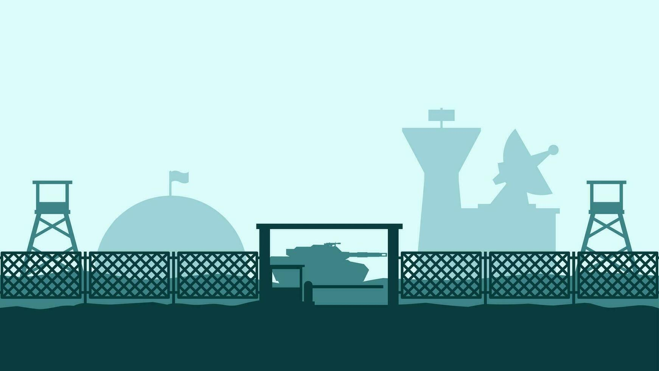

BASE 2: 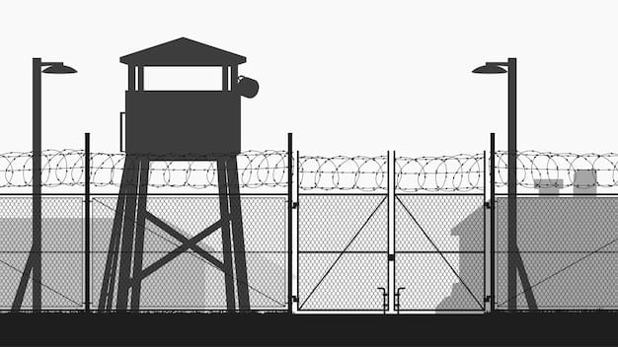

MISILE 1:

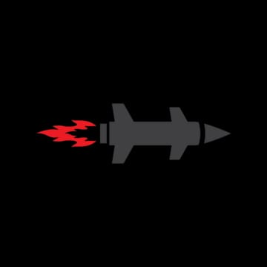

MISILE 2:



MISILE 3:

